

**MALAD KANDIVALI EDUCATION SOCIETY’S**

**NAGINDAS KHANDWALA COLLEGE OF COMMERCE, ARTS & MANAGEMENT STUDIES & SHANTABEN NAGINDAS KHANDWALA COLLEGE OF SCIENCE**

**MALAD [W], MUMBAI – 64**

AUTONOMOUS INSTITUTION

(Affiliated To University Of Mumbai)

Reaccredited ‘A’ Grade by NAAC | ISO 9001:2015 Certified

**CERTIFICATE**

Name: DHWANI PATHAK

Roll No: 400 Programme: BSc IT/CS Semester: III

This is certified to be a bonafide record of practical works done by the above student in the

college laboratory for the course **Hybrid Application Development (classcode: 2037UCSMD)** for the partial fulfilment of Third Semester of BSc IT/CS during the

academic year 2020-21.

The journal work is the original study work that has been duly approved in the year 2020-21

by the undersigned.

|  |  |  |
| --- | --- | --- |
| _____________________  External Examiner |  | ____________________  Mr. Gangashankar Singh  (Subject-In-Charge) |
| Date of Examination: | (College Stamp) |  |

Class: S.Y. B.Sc. IT Sem- III Roll No: 400

Subject: Hybrid Application Development

INDEX

|  |  |  |  |
| --- | --- | --- | --- |
| Sr. No | Date | Topic | Sign |
| 1 | 27/07/2020 | AngularJS Data Binding |  |
| 2 | 7/08/2020 | AngularJS Directives |  |
| 3 | 14/08/2020 | AngularJS Controllers |  |
| 4 | 25/08/2020 | AngularJS Events |  |
| 5 | 08/09/2020 | Ionic Create and Build First Project |  |
| 6 | 12/09/2020 | Ionic Adding Cordova Android Platform |  |
| 7 | 19/09/2020 | Ionic Create, Generate and Add Pages |  |
| 8 | 29/09/2020 | Ionic Use Tabs Starter Template |  |

1-DATA BINDING

* *Data-binding in AngularJS apps is the automatic synchronization of data between the model and view components.*
* *The way that AngularJS implements data-binding lets you treat the model as the single-source-of-truth in your application.*
* *The view is a projection of the model at all times. When the model changes, the view reflects the change, and vice versa.*

# OUTPUT:

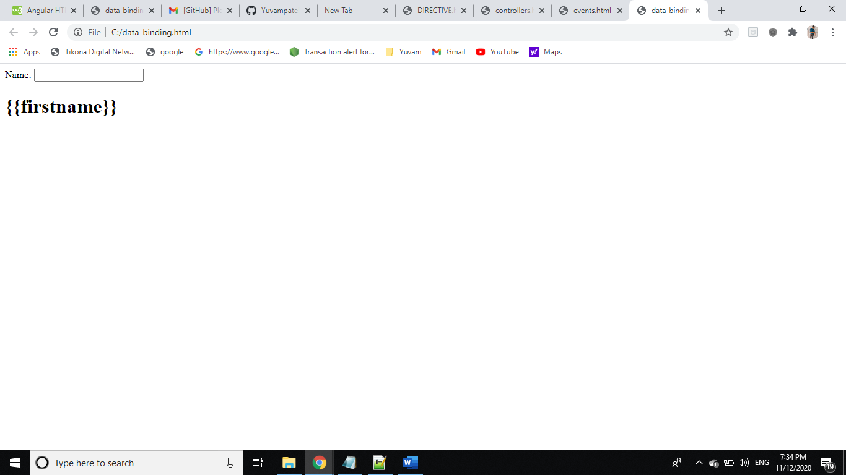

2-ANGULARJS DIRECTIVES

* *AngularJS comes with a set of these directives built-in, like ngBind, ngModel, and ngClass. Much like you create controllers and services, you can create your own directives for AngularJS to use.*
* *When AngularJS bootstraps your application, the HTML compiler traverses the DOM matching directives against the DOM elements.*

# OUTPUT:

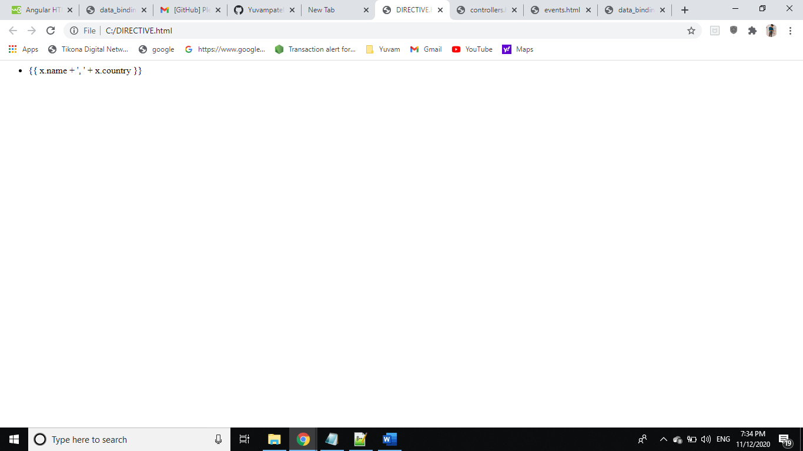

3-ANGULARJS CONTROLLERS

* In AngularJS, a Controller is defined by a JavaScript **constructor function** that is used to augment the AngularJS Scope.
* Controllers can be attached to the DOM in different ways. For each of them, AngularJS will instantiate a new Controller object, using the specified Controller's constructor function:

1. The ngController directive. A new child scope will be created and made available as an injectable parameter to the Controller's constructor function as $scope.
2. A route controller in a $route definition.
3. The controller of a regular directive, or a [component directive](https://docs.angularjs.org/guide/component).

# OUTPUT:

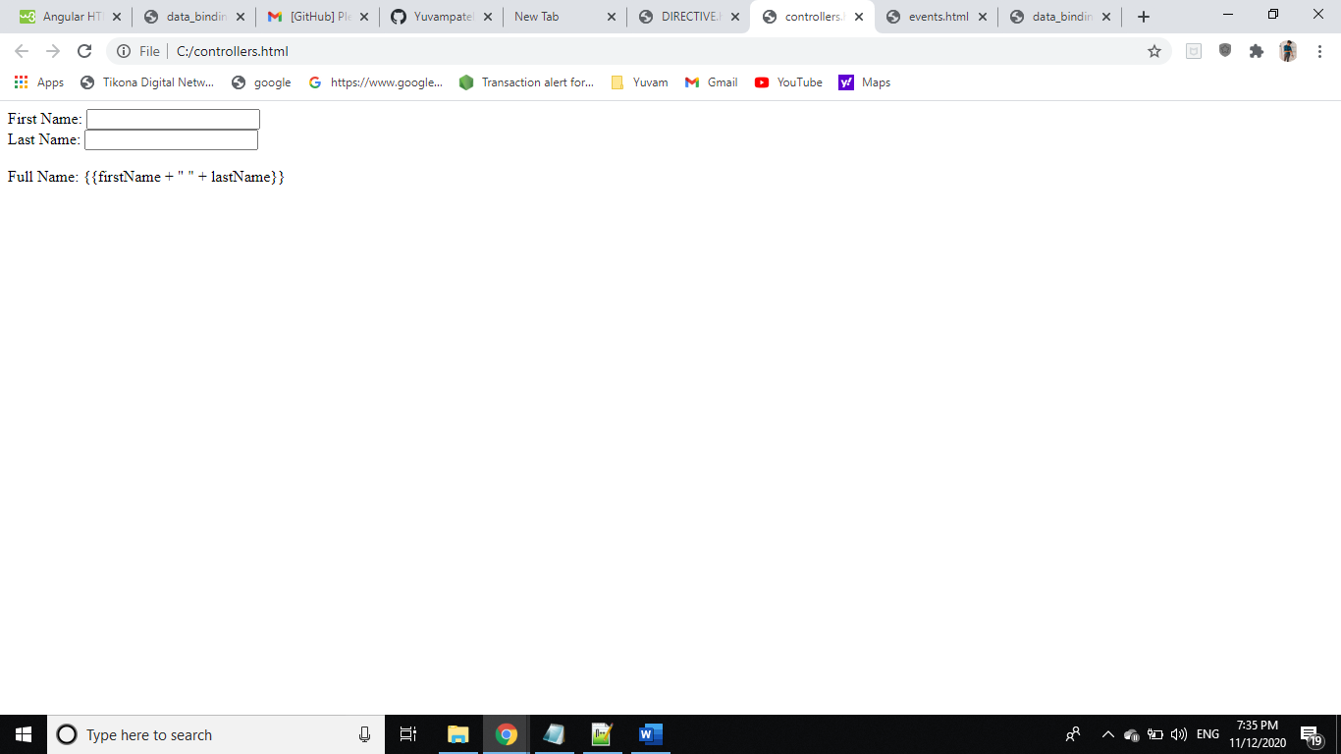

4-ANGULARJS EVENTS

* AngularJS includes certain directives which can be used to provide custom behavior on various DOM events, such as click, dblclick, mouseenter etc.
* You can add AngularJS event listeners to your HTML elements by using one or more of these directives:
* ng-blur
* ng-change
* ng-click
* ng-dblclick
* ng-focus
* ng-keydown
* ng-keyup
* ng-keypress
* ng-mousedown
* ng-mouseenter
* ng-mouseleave
* ng-mousemove
* ng-mouseover
* ng-mouseup

# OUTPUT:

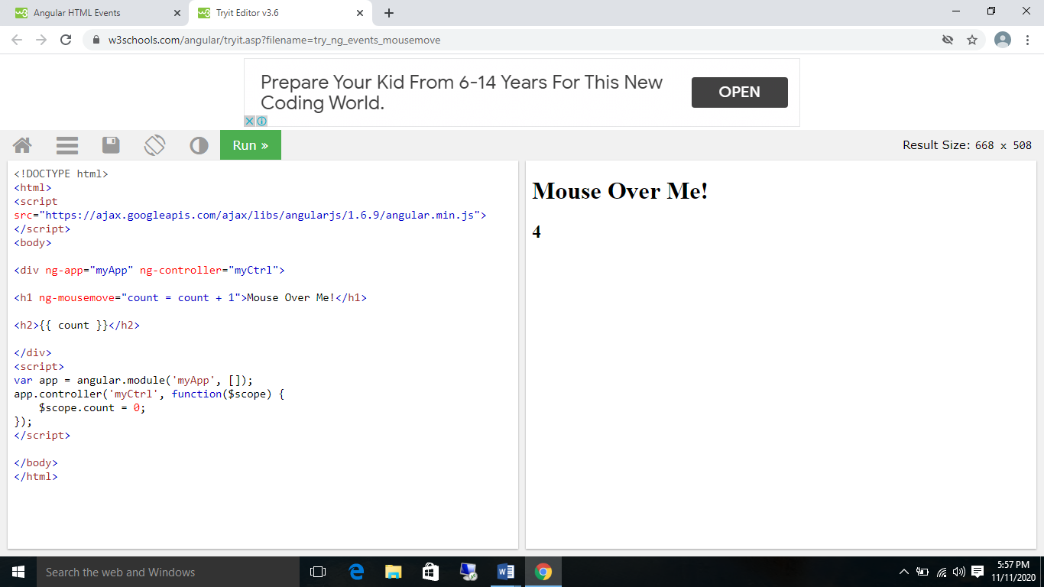

5-IONIC CREATE AND BUILD FIRST PROJEC

## *How to create and ionic web app:*

#### The requirement for creating an Ionic web app is:

#### Node Js

#### NPM

#### Run the below commands in the command prompt or terminal

## Steps for creating Ionic Web app:

### Install ionic using npm install -g ionic

### 2. Get ionic info using ionic info

### 3. To create an ionic app type ionic start <app name>

### 4. Then it will ask to choose a framework if you want to make it in angular choose angular

### 5. Then to start running the ionic web page in the server type ionic serve.

### 6. To access the web page go on <http://localhost:8100>

# OUTPUT:

### 

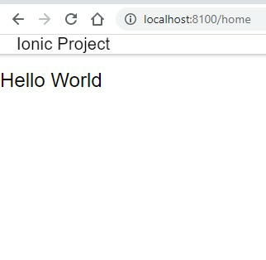

6-IONIC ADDING CORDOVA ANDROID PLATFORM

## *How to create and Ionic Android app:*

### Steps to create an ionic android app:

### After you have built the web app next command you should type is ionic cordova platform add android .This will add and android platform to your web app directory.

### 2. Now type ionic cordova build android to start building your android app.

### 3. Now type ionic cordova run android , If you have connect your machine to a phone and turned on USB debugging the app will export to your pc and if you are running an emulator the out will be like this.

# OUTPUT:

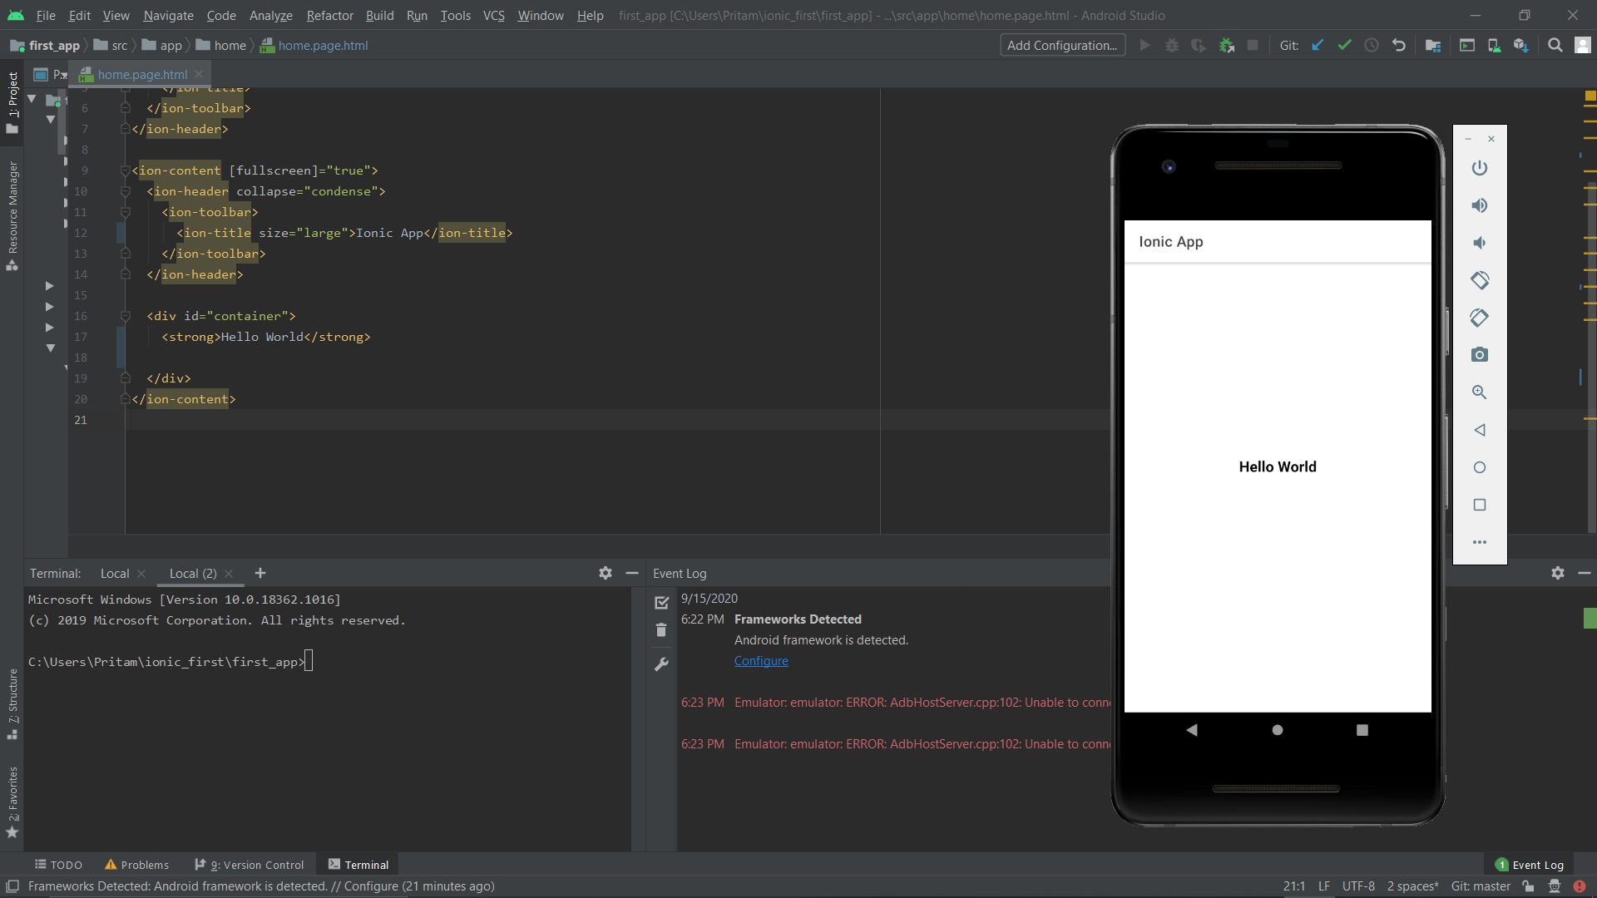

7-IONIC CREATE, GENERATE AND ADD PAGES

* Ionic generate uses the Angular CLI to generate features such as pages, components, directives, services, etc.
* For a full list of available types, use npx ng g --help
* For a list of options for a types, use npx ng g <type> --help

You can specify a path to nest your feature within any number of subdirectories. For example, specify a name of "pages/New Page" to generate page files at src/app/pages/new-page/.

# OUTPUT:

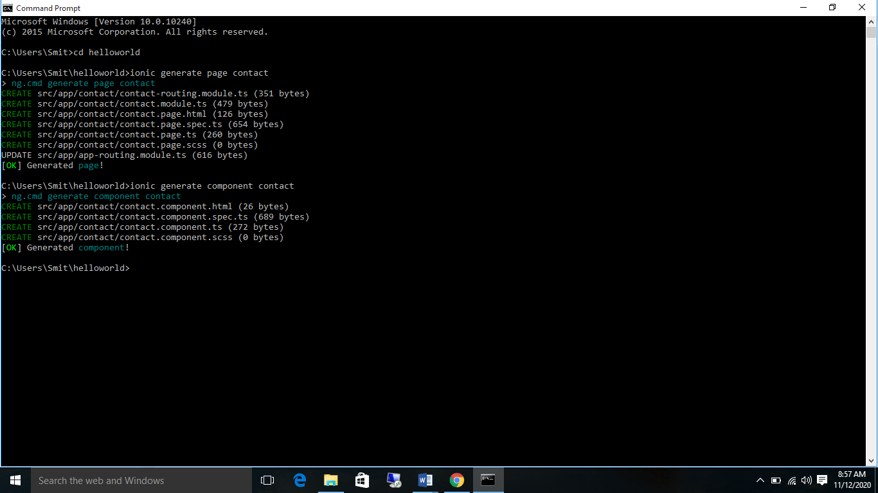

8-IONIC USE TABS STARTER TEMPLATE

To start a new app, open your terminal/command prompt and run:

ionic start MyIonicProject tabs --type**=**ionic-angular

* start will tell the CLI create a new app.
* MyIonicProject will be the directory name and the app name from your project.
* tabs will be the starter template for your project.

# *OUTPUT:*

